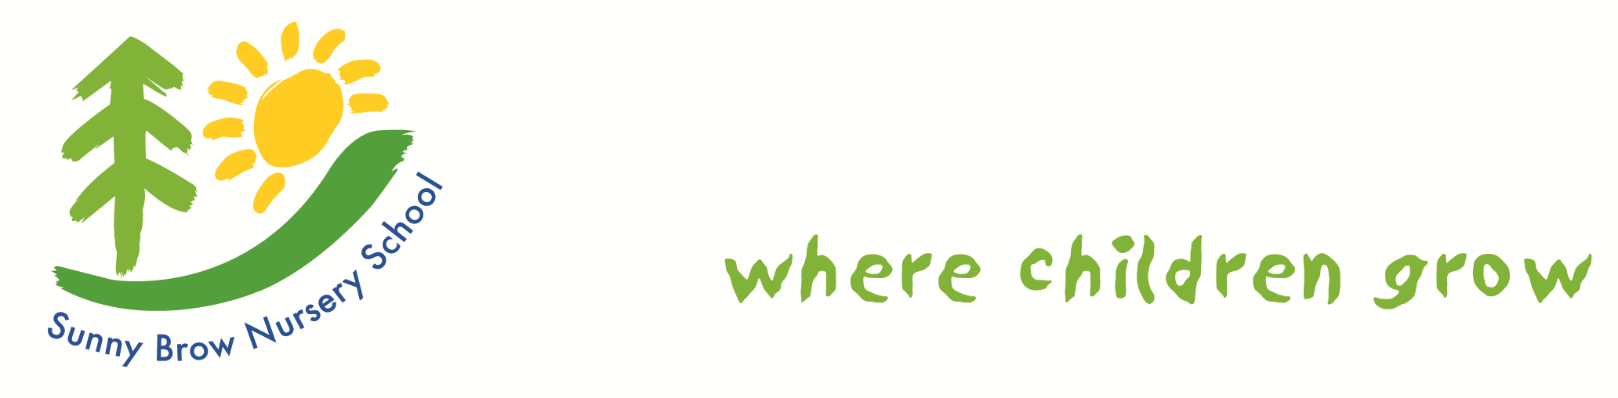

Charging and Remissions Policy

Reviewed: September 2025
Next Review September 2026

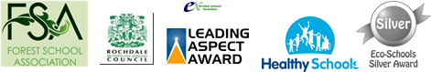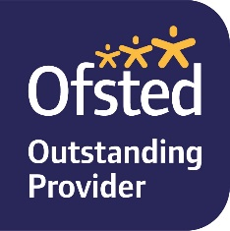

Introduction
Sunny Brow Nursery School is committed to the principle of free, high quality, Early Years education. No charges are made for any activity undertaken as part of the universal 15 hours (5 x 3 hours 9:00-12:00 daily) or the extended hour offer 30-hour Government funded sessions (5 x 6 hours daily 9:00-3:00 daily).
Educational Visits/Visitors
If an educational visit is being organised parents may be invited to contribute to the costs of the trip. All contributions are voluntary and if we do not receive enough money to cover the trip and there is enough money in Income Generated fund the school will make the difference up. If the trip goes ahead, it may include children of parents who have not contributed, these children will not be identified nor treated differently from any other child. However, if there are insufficient funds in the Income Generated account the visit will be cancelled.
No activities will take place outside school hours. No Residential trips will be made
Voluntary Contributions – Snacks
All children have access to snacks during the school session. These consist of milk, water (from a chilled water machine, fruit/veg sticks and low-salt crackers. We ask parents to contribute towards the cost (£1 per week), Or £10 per term. If a child is vegan parents will be asked to supply suitable snack/drinks and will not be required to contribute financially. Nursery schools are not included in the Government/Local Authority initiative “Fruit to Schools”.
It is assumed that all parents will accept this responsibility but no checks are made regarding who has / has not paid; and no pressure would be placed on those who feel unable (financially) to contribute.
Consequently, there is no remission strategy for this voluntary contribution.
EXTRA SERVICES CHARGES
Early start/late finish £8.00 per hour
Additional education sessions (If not covered by Working Families Funding) £8.00 per hour
Any hours above Working Families Entitlement 30 will be charged at the above rates – all are subject to availability.
Sunny Brow Nursery School offers a before and after school service, which is charged at £8 per hour. Parents can access these in addition to either their 15 hour or 30 hours. These are not compulsory – and parents opt for sessions which support their need to work/study.
Parents who purchase before and/or after school session will be invoiced through Arbor and will receive a copy of their requirements, informing them of the terms and conditions. Sunny Brow Nursery School will not charge for any sessions cancelled by the school e.g. adverse weather conditions, no heating, staff illness that cannot be covered by agency workers. These sessions will be credited. If, at the end of the academic year, parents are found to be ‘in credit’, then remission payments are made (by BACS or cheque) to the payer’s account.
There is no remission if a parent chooses for their child not to attend.
Charges are made at a rate set by the Governing Board, wherever possible, in line with local providers.

Bank Charges
In the event of a charge being made to the school in respect of returned cheques the charge will be passed on to the person who issued the cheque.

Remissions
The Governing Body may decide to remit in full or in part the cost of any extra service charge for parents who are facing family hardship. Authorisation for such a remission will be by in confidence by the Headteacher and with consultation with the Chair of Governors.
p:\office\policies\charging and remissions policy2022.docx

